**KIET Group of Institutions, Ghaziabad**

***Computer Science & Engineering***

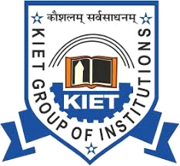

**Internship Report**

**on**

**Style a basic webpage(Easy) and**

**Build a simple React application(Intermediate)**

**MLSA Internship**

**Duration :**

8 September – 29 October , 2024

**Submitted By:**

**Rohan Singh**

**B.Tech/CSE(5-C)**

**University roll no.-2200290100136**

**ACKNOWLEDGEMENT**

I’ve got this golden opportunity to express my kind gratitude and sincere thanks to my Head of Institution, KIET Group of Institutions of Engineering and Technology, and Head of Department of “**Computer Science Engineering”** for their kind support and necessary counselling in the preparation of this project report. I’m also indebted to each and every person responsible for the making up of this project directly or indirectly.

I must also acknowledge or deep debt of gratitude each one of my colleagues who led this project come out in the way it is. It’s my hard work and untiring sincere efforts and mutual cooperation to bring out the project work. Last but not the least, I would like to thank my parents for their sound counselling and cheerful support. They have always inspired us and kept our spirit up.

**Rohan Singh**

**B.Tech / CSE**

**5 - C**

**University Roll No: 2200290100136**

**Introduction of Project Internship**

Welcome to this introduction report documenting my journey of learning HTML, CSS, JavaScript and React. This report aims to provide an overview of my progress, experiences, and aspirations in the world of web development.

**HTML(HYPERTEXT MARKUP LANGUAGE)**

HTML is the foundation of web development. It's used to structure the content on web pages. My goals for learning HTML include:

* Creating well-structured web pages with semantic HTML5 elements.
* Understanding the Document Object Model (DOM) and its significance in web development.
* Building accessible and responsive web content.

**CSS(CASCADING STYLE SHEET)**

CSS is responsible for styling web pages and making them visually appealing. My goals for learning CSS include:

* Crafting visually engaging user interfaces with CSS.
* Mastering responsive design techniques to ensure compatibility across devices.

**JAVASCRIPT**

JavaScript is a dynamic and powerful scripting language used for adding interactivity and functionality to web pages. My goals for learning JavaScript include:

* Writing clean, efficient, and maintainable JavaScript code.
* Implementing interactive features, such as form validation and user interfaces.

**REACT**

React is a free and open-source front-end JavaScript library for building user interfaces based on components by Facebook Inc. It can be used to develop single-page, mobile, or server-rendered applications with frameworks like Next.js. My goals for learning React include:

* Creating advanced UIs
* Accelerating page loading

**Overview of Project**

Here's an overview of learning HTML, CSS, and JavaScript:

**HTML (Hypertext Markup Language)**

What is HTML?

* HTML is the foundation of web development and stands for "Hypertext Markup Language."
* It is a markup language used to structure the content of a web page.
* HTML uses a system of tags to define elements like headings, paragraphs, links, images, and lists.

**CSS (Cascading Style Sheets)**

What is CSS?

* CSS stands for "Cascading Style Sheets" and is used for styling web pages.
* It allows you to control the layout, colors, fonts, and overall visual presentation of web content.
* CSS styles are applied to HTML elements, enhancing the aesthetics and user experience of a website.

**JAVASCRIPT**

What is JavaScript?

* JavaScript is a versatile programming language used for adding interactivity and functionality to web pages.
* It enables dynamic client-side behavior, such as form validation, animations, and AJAX requests.
* JavaScript is a key component in creating modern web applications and enhancing user experiences.

**REACT**

What is React?

* **JavaScript Library**: React is an open-source JavaScript library developed by Facebook, primarily used for building user interfaces, especially for single-page applications.
* **Component-Based**: It allows developers to create reusable UI components, which makes it efficient for developing complex and interactive web applications.
* **Virtual DOM**: React uses a virtual DOM to update only the parts of the web page that have changed, improving performance and user experience.

**Project Description: PG Life Website**

Objective:

The PG Life website project is based on finding nearby paying guests accommodation as per the location, budget and requirements of the seeker. At PG Life, we empower you with the tools and information you need to make an informed decision. With a few clicks, you can access detailed listings, high-quality photographs, and essential information about PG facilities and amenities.

Key Features:

1.Navigation Bar:

The navigation bar is designed to be intuitive, with a collapsible menu for better mobile responsiveness. It contains the logo and sign up and login buttons using which a user can sign in or login to the website.

2.Homepage Content:

The homepage features a dynamic layout with three main sections: left, center, and right.

The home page of my website contains a search bar where a person can search his PG Accommodation as per his/her convenience. If he/she wants to take a PG in a major city like Delhi, Mumbai, Hyderabad or Bengaluru, then he/she can click on the buttons provided below the search bar that would take him/her directly to the PG’s in these major cities.

3.Interactive Elements:

A Signup form appears after clicking on the signup button to create a new account as per the required details that have to be filled.

Some buttons and links have been provided at the bottom to minimize a person’s effort while searching for his PG. He/She can directly click on those buttons and links to see the PGs available in that area.

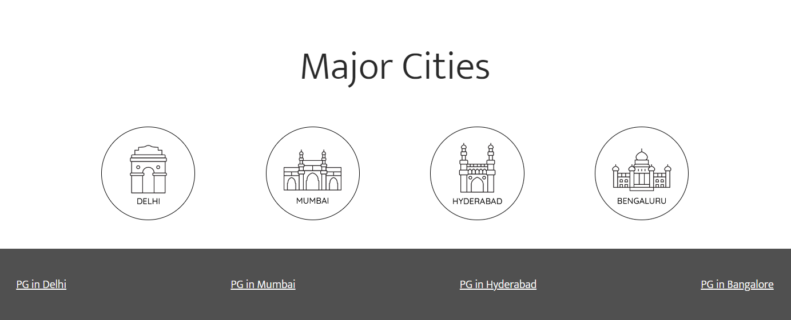

Signup form:

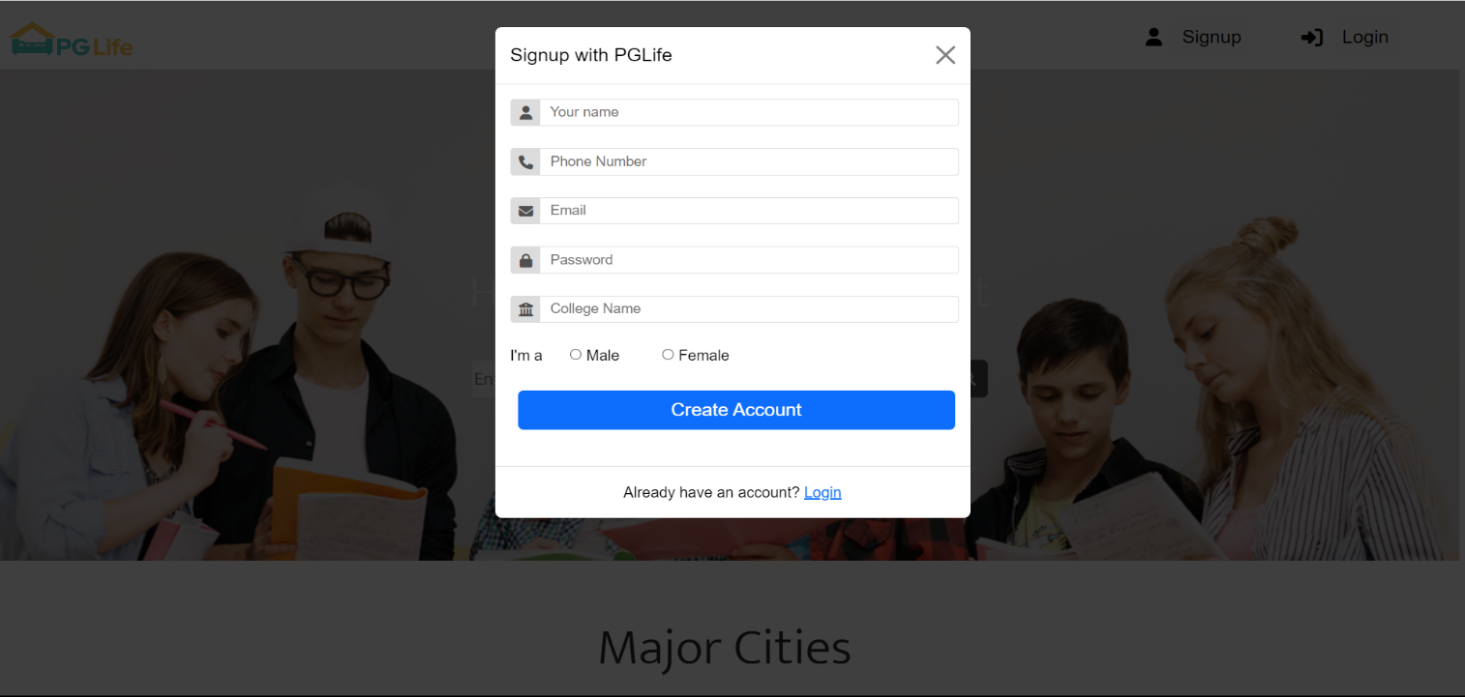

Home Page:

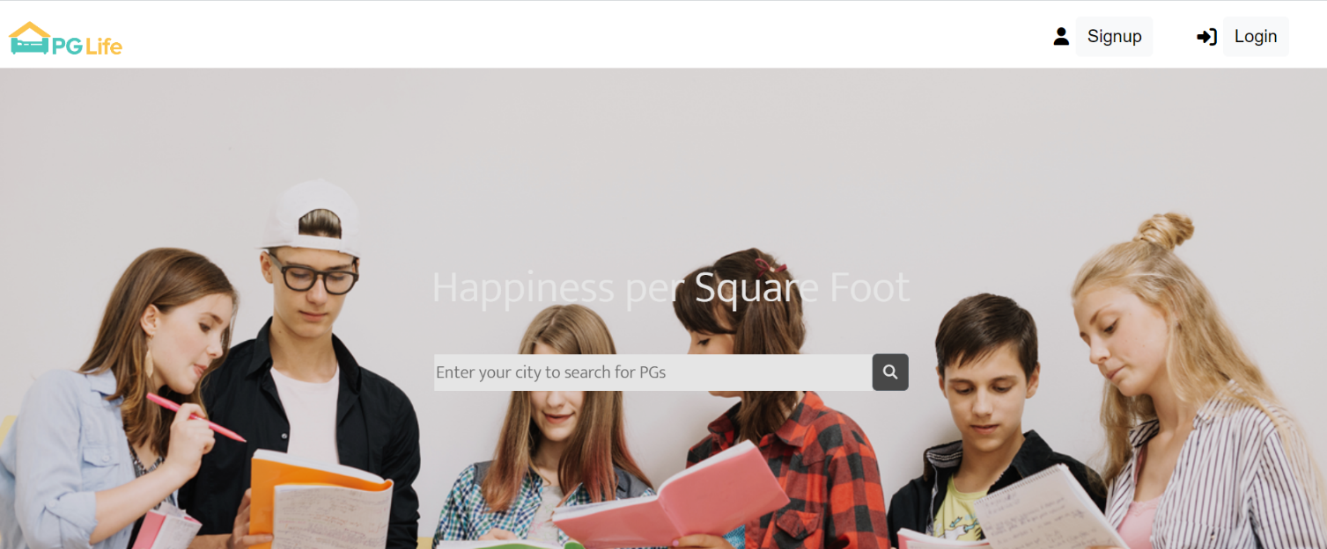

**Project Description: Plan-With-Rohan**

Objective:

The objective of the "Plan With Rohan" page is to offer users a curated list of travel destinations across India, each with essential information such as cost, a brief description, and imagery to help them choose a travel experience. The page allows users to explore different travel options and customize their selection by removing options they are not interested in.

Key Features:

1. Destination Cards: Each card represents a destination with details like price, location, description, and an image, making it easy for users to browse available options visually.
2. Removal Functionality: The "Not Interested" button on each card lets users remove destinations they aren’t interested in, helping them tailor the list to their preferences.
3. Responsive Layout: The grid layout allows for a clean, organized presentation of destinations, enhancing user experience and making it easy to view multiple options at once.
4. Read More Links: Each card includes a "Read More" link, allowing users to access additional information about a destination without overcrowding the main page.
5. Price Display: The cost of each trip is prominently displayed, aiding users in making quick financial decisions regarding their travel options.

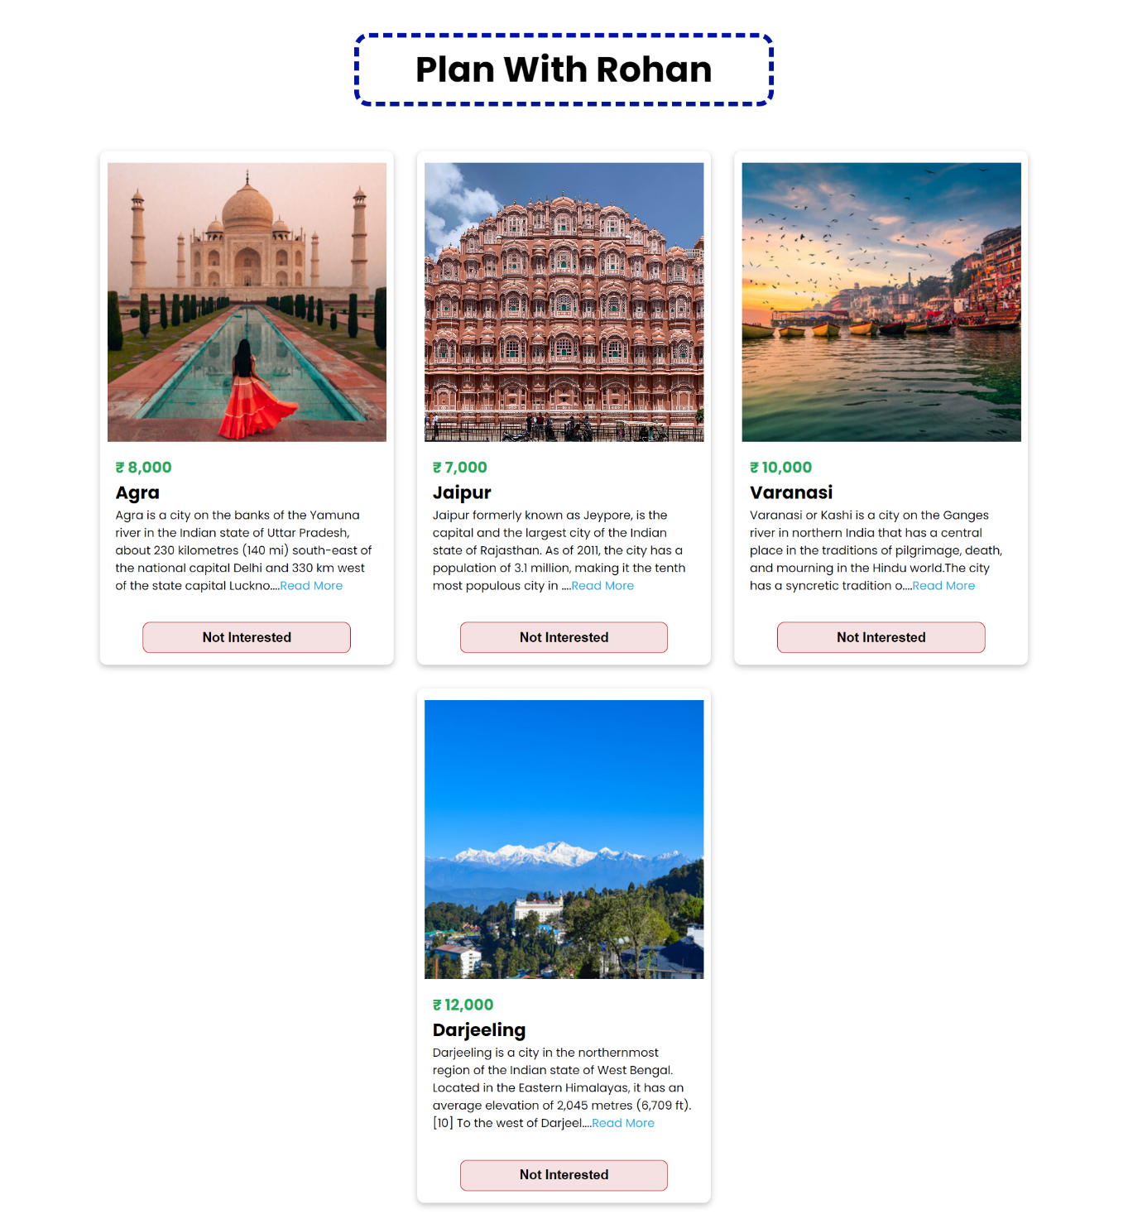

**Conclusion:**

**Building the Foundations of Web Development**

Over the course of our internship, we dived headfirst into the fundamental building blocks of web development, becoming well-versed in HTML, CSS, and JavaScript and React. This chapter marks the end of our exciting learning adventure, but it certainly signifies the beginning of a promising career in web development.

**A Solid Foundation in HTML**

Our internship commenced with an in-depth exploration of HTML (Hypertext Markup Language). We learned to create the skeletal structure of web pages, infusing them with meaningful content and semantics. Understanding the role of tags, attributes, and elements was crucial in crafting web pages that are both user-friendly and accessible. The knowledge gained here will serve as the cornerstone for creating web content that resonates with diverse audiences.

**Styling with CSS**

The art of web design took center stage as we delved into Cascading Style Sheets (CSS). Learning how to apply styles, fonts, colors, and layouts was a creative endeavor that allowed us to bring our web pages to life. The versatility of CSS empowered us to produce visually stunning and responsive websites, capable of adapting to various devices and screen sizes. The synergy between HTML and CSS provided us with the skills to craft web experiences that are not only functional but also aesthetically pleasing.

**Interactivity with JavaScript**

The internship reached new heights as we delved into the world of interactivity through JavaScript. We learned to create dynamic, user-friendly web applications, enhancing user experiences and engagement. Understanding concepts such as variables, functions, and event handling opened up a world of possibilities for us to develop practical web solutions. The ability to harness JavaScript to manipulate the Document Object Model (DOM) transformed our static web pages into dynamic and responsive applications

**Advanced UI with React**

In building the "Plan With Rohan" webpage, React's component-based structure was used to create individual destination cards, each displaying unique travel data through props. State management allows users to remove cards by clicking "Not Interested," updating the displayed list without reloading the page. This approach enables a smooth, interactive experience while making it easy to manage and update destinations dynamically.

**A World of Opportunities**

As we wrap up this internship, we carry with us a toolbox filled with valuable skills and knowledge. We are now equipped to embark on a journey of web development, ready to tackle more advanced concepts and technologies. The world of web development is vast and ever-evolving, with opportunities that are limited only by our imagination. Whether we choose to specialize in front-end development, delve into back-end development, or explore the world of full-stack development, the foundation we have built during this internship serves as a solid launchpad.

**Future Scope**

The future scope of this internship is promising, spanning specialization in web development domains, web application creation, open source contributions, job opportunities in diverse industries, ongoing learning and certifications, networking, mentoring, adaptation to emerging technologies, and global career prospects. The strong foundation in HTML, CSS, JavaScript and React obtained during the internship sets the stage for a dynamic and globally relevant web development career. With the ever-evolving digital landscape, this knowledge opens doors to a multitude of opportunities, ensuring a bright future in the field.